FLAP pilot 1 and 2 analysis pipeline

First, we find the PRL location during the fixation flicker task (I guess we used the ‘post’ session). Files are called ‘AC_FLAPfixationflicker21_11_18_10_10’. Script to extract is ‘extract_flap_fixation’ on github, oculomotor analysis. This allows us to have the yellow dot below. 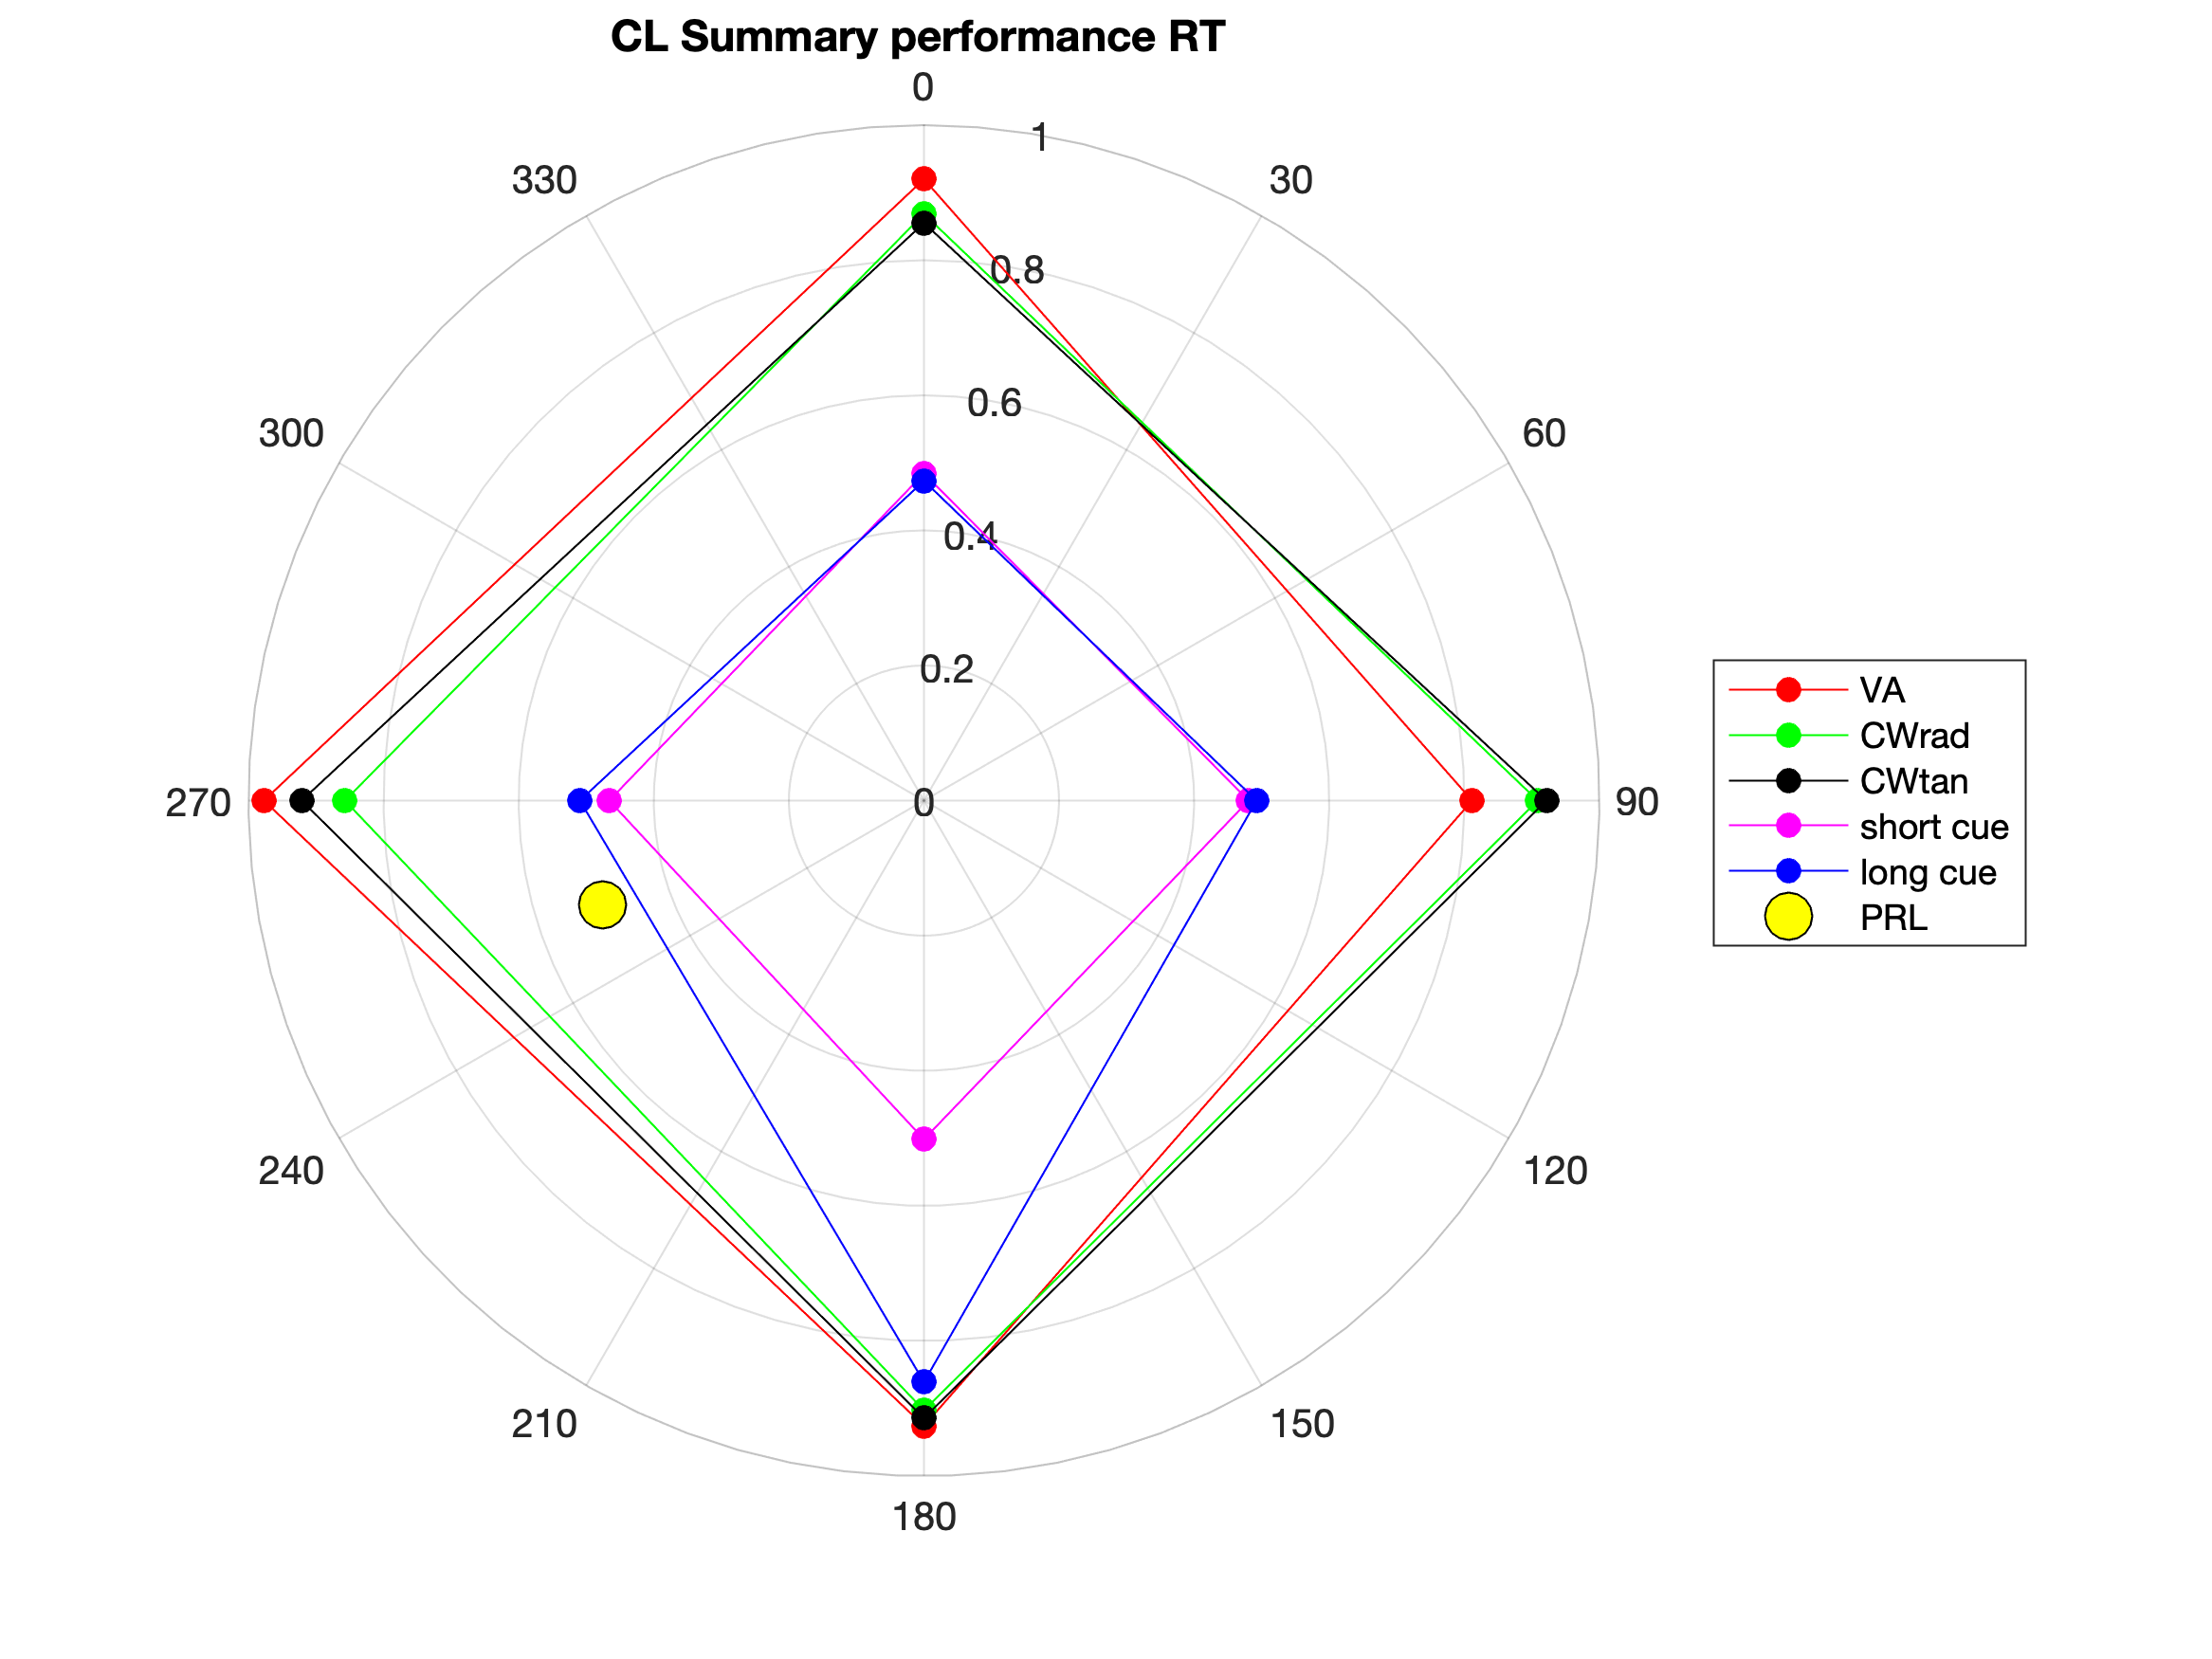

This yellow dot is an estimation of the PRL location from distributions like this one:

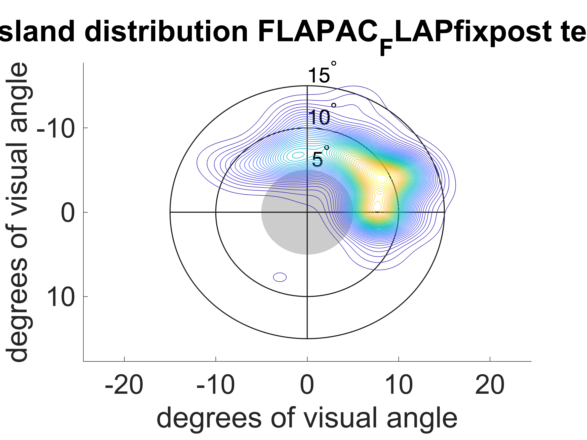

the script ‘AcuityCrowdingAttentionAnalysisNew’ provides the RT and % accuracy for the 4 PRL locations during the ACA task. Example files for this is ‘JH_FLAP_ACA21_11_10_11_50’. Flap/analysis code/oculomotor analysis

Data files are in Download/FLAP/BGC new pilots

Zzzdio= general summary (non-prl specific)

zzzsummarytable = summary divided by PRL

general summary example (from JH):

|  |  |
| --- | --- |
| VA | 1.1777 |
| cw_rad | 3.8734 |
| cw_tan | 2.2289 |
| attshortCueRT | 0.5687 |
| attshortUncueRT | 0.7484 |
| attshortCueperc | 76.5432 |
| attshortUncuePerc | 81.25 |
| attlongCueRT | 0.517 |
| attlongUncueRT | 0.8375 |
| attlongCueperc | 72.5 |
| attlongUncuePerc | 67.0886 |

PRL-specific summary example (from JH):

|  |  |  |  |  |  |  |
| --- | --- | --- | --- | --- | --- | --- |
| JH |  |  | up | right | down | left |
| VA |  | Acc | 0.55 | 0.8 | 0.65 | 0.65 |
|  |  | RT | 0.55 | 0.53 | 0.52 | 0.51 |
| Crowding | radial | Acc | 0.35 | 0.7 | 0.7 | 0.75 |
|  |  | RT | 0.59 | 0.55 | 0.53 | 0.77 |
|  | tangential | Acc | 0.55 | 0.6 | 0.65 | 0.6 |
|  |  | RT | 0.5352 | 0.60733 | 0.5705 | 0.76287 |
| Attention | short | Acc | 0.13333 | 0 | 0.05 | 0 |
|  |  | RT | 0.30623 | 0.067543 | -0.52403 | -0.10651 |
|  | long | Acc | 0.13421 | 0.05 | -0.3 | -0.1 |
|  |  | RT | -0.4911 | -0.11306 | -0.64278 | -0.39872 |

FLAP_vss_analysis_UAB_expanded_sample

